TIES 452 (2014): Guidelines for the 4th computer class demo
Your surname:
Your first name:

Task 1: Prepare CWM environment
- Find out where Python is installed. Likely locations:
  - c:\Python27
  - c:\MyTemp\Python27
  - or some other location or version
- If you don’t have Python installed, install it (e.g. into c:\MyTemp\Python27).
- Add the python folder into your PATH variable. Example:
  - set PATH=%PATH%;c:\Python27\
- Now you should be able to run python from any folder. Open command line. Go directly into c:\. Test python by running:
  - python --version
You should see the version of python. If not, something went wrong.
- Download CWM from http://users.jyu.fi/~olkhriye/ties452/demos/demo4/cwm-1.2.1s.zip and unpack it into a folder of your choice (e.g. into c:\MyTemp\CWM).
- Open command line. Go into CWM folder. To check if CWM is working run:
  - python cwm --help
You should see a long list of commands and options for CWM.

Task 2: Try out forward chaining reasoning in CWM (via N3 rules) and Protégé (via SWRL rules).
- Download RDF data from http://users.jyu.fi/~olkhriye/ties452/demos/demo4/dataNew.n3 (the data is in Notation3) and RDF data from http://users.jyu.fi/~olkhriye/ties452/demos/demo4/dataNew.owl (the data is in Notation3 to be used with Protégé 4.x(5.x)).
- Prepare a file called rule.n3. This file will contain your rules in Notation3 (using N3 logic).
- Create the rules below in both languages (N3 and SWRL). Run CWM reasoner for each rule separately and for each rule provide the output of reasoning. Apply SWRL rules in Protégé and provide correspondent screenshots of the results.

Tip: You might need some special built-in constructs of N3 logic and SWRL rules.
Look here: http://www.w3.org/2000/10/swap/doc/CwmBuiltins
Look here: http://www.daml.org/rules/proposal/builtins.html#8.1
example
Property ex:hasChild has an inverse property ex:hasParent.
Make a rule that creates inverse statements of statements having ex:hasChild as their predicate.
N3 Rule(s)
@prefix ex: <http://www.smith-family.com/familyOntology.owl#> .
{?x ex:hasChild ?y} => {?y ex:hasParent ?x} .
Result of CWM
c:\MyTemp\Programs\cwm-1.2.1s>python cwm data.n3 --filter=rule.n3
#Processed by Id: cwm.py,v 1.197 2007/12/13 15:38:39 syosi Exp
# using base file:///MyTemp/Programs/cwm-1.2.1s/data.n3
# Notation3 generation by
# notation3.py,v 1.200 2007/12/11 21:18:08 syosi Exp
# Base was: file:///MyTemp/Programs/cwm-1.2.1s/data.n3
@prefix : <#> .
@prefix ex: <http://www.smith-family.com/familyOntology.owl#> .

:alice ex:hasParent :jane,
:mark .
:bill ex:hasParent :alice,
:andy .
:charles ex:hasParent :dana,
:harry .
:harry ex:hasParent :alice,
:andy .
:john ex:hasParent :bill,
:kate .
:mary ex:hasParent :bill,
:kate .
:robert ex:hasParent :dana,
:harry .
#ENDS
SWRL Rule(s)
hasChild(?x, ?y) -> hasParent(?y, ?x)
Result of Protégé
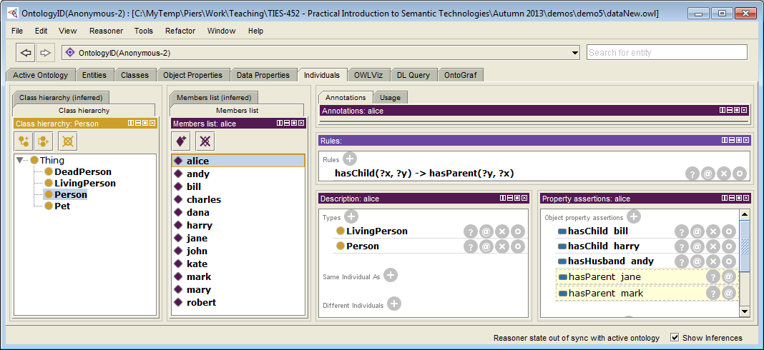
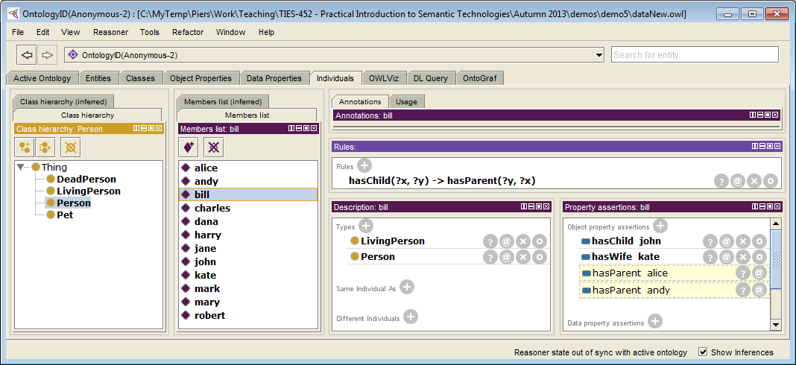
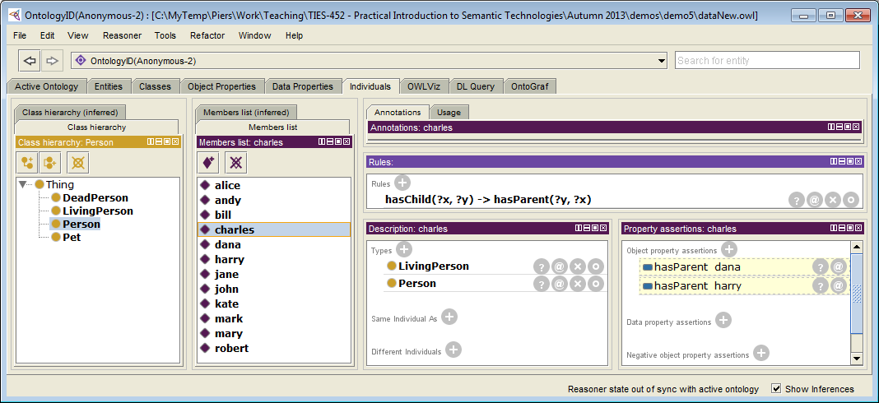
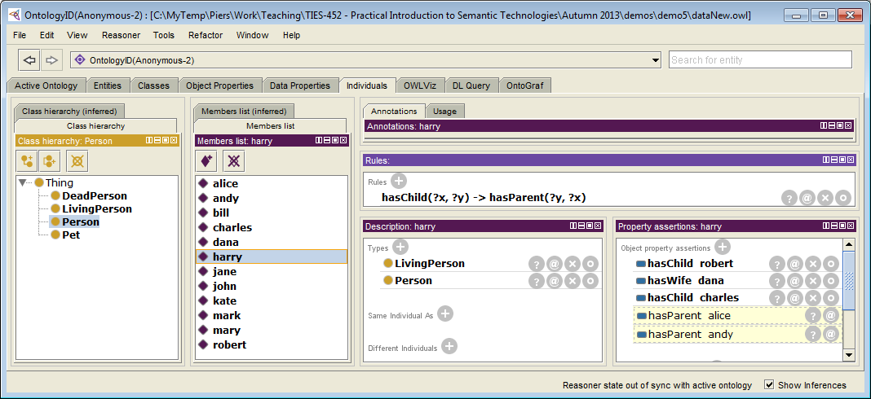
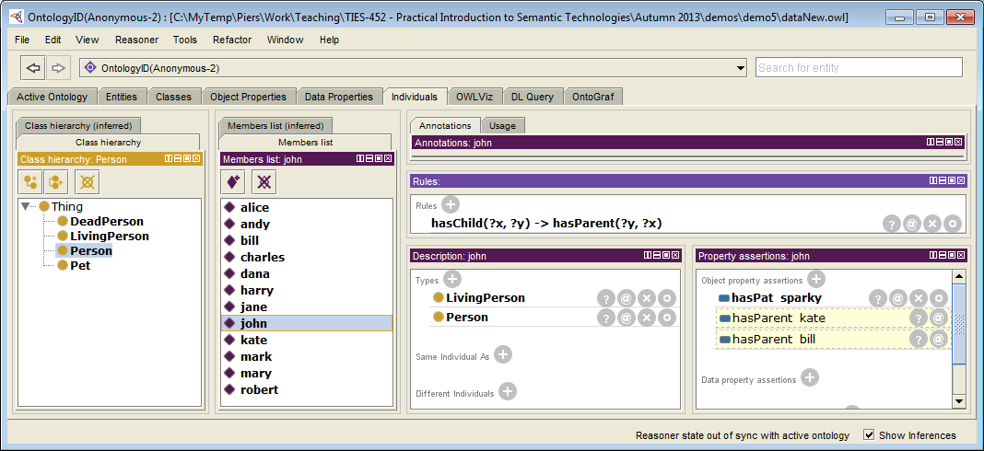
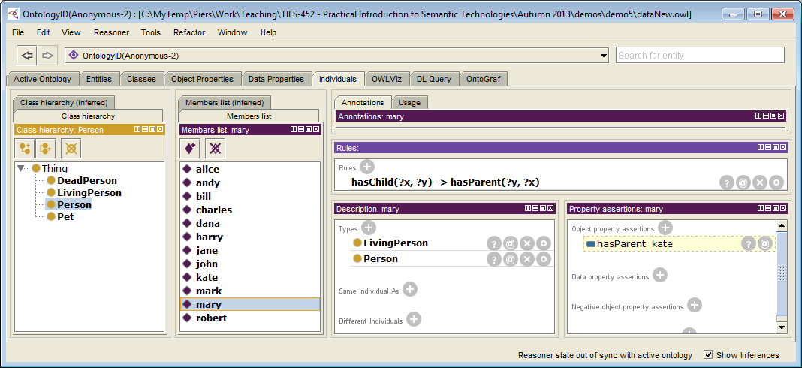
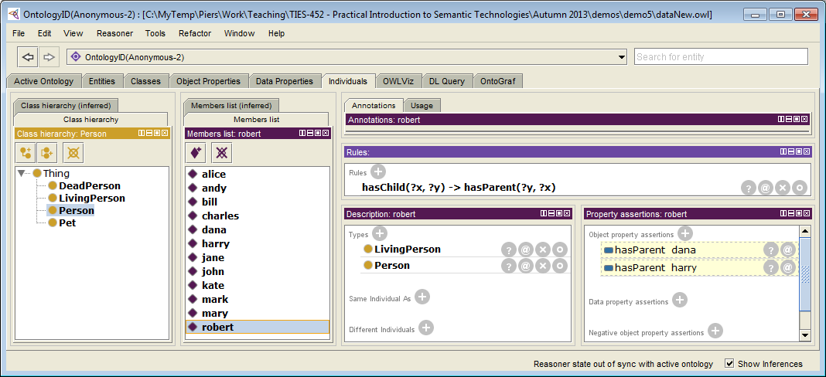

Q1: An individual belongs to class ex:Widow if and only if that individual has a husband that is dead.
Having husband is expressed using property ex:hasHusband.
Dead person is a person that belongs to class ex:DeadPerson.
Make a rule that annotates all widows.
Rule(s)
{?x ex:hasHusband ?y . ?y a ex:DeadPerson} => {?x a ex:Widow}.
Result of CWM
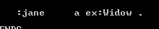
SWRL Rule(s)
DeadPerson(?y), Person(?x), hasHusband(?x, ?y) -> Widow(?x)
Result of Protégé
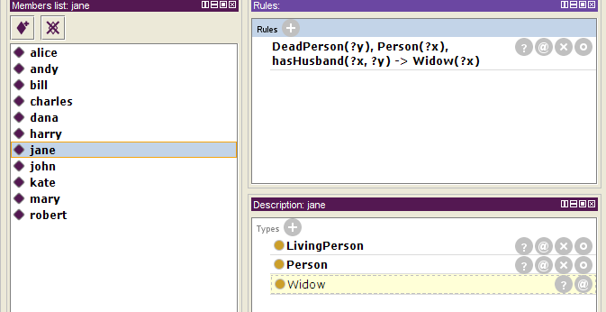

Q2: An individual belongs to class ex:PetLover if and only if that individual has a pet.
Having a pet is expressed using property ex:hasPet.
Make a rule that annotates all pet lovers.
Rule(s)
{?x ex:hasPet ?y . ?y a ex:Pet} => {?x a ex:PetLover}.
Result of CWM
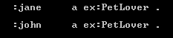
SWRL Rule(s)
Person(?x), hasPet(?x, ?p) -> PetLover(?x)
Result of Protégé
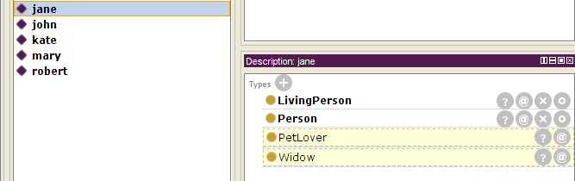

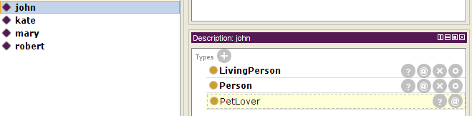

Q3: An individual belongs to class ex:Grandparent if and only if that individual has a child that has a child.
Having a child is expressed using property ex:hasChild.
Make a rule that annotates all grandparents.
Rule(s)
{?x ex:hasChild ?y . ?y ex:hasChild ?z} => {?x a ex:Grandparent}.
Result of CWM
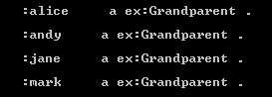
SWRL Rule(s)
-- paste SWRL rule here –
Result of Protégé
-- paste the screenshots from Protege here –

Q4: Connect all cousins with property ex:hasCousin.
Rule(s)
@prefix ex: <http://www.smith-family.com/familyOntology.owl#> .
@prefix log: <http://www.w3.org/2000/10/swap/log#>.
{
?x ex:hasChild ?y.
?x ex:hasChild ?z.
?y ex:hasChild ?a.
?z ex:hasChild ?b.
?y log:notEqualTo ?z.
}
=> {?a ex:hasCousin ?b}.
Result of CWM
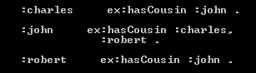
SWRL Rule(s)
-- paste SWRL rule here –
Result of Protégé
-- paste the screenshots from Protege here –

Q5: In case a person does not have a connection via ex:hasChild property to the individual that is connected via the same property with a spouse of that person (wife or husband), then build a connection between the person and individual via ex:hasStepchild property.
Rule(s)
-- paste content of rule.n3 here –
Result of CWM
-- paste the result of CWM here --
SWRL Rule(s)
-- paste SWRL rule here –
Result of Protégé
-- paste the screenshots from Protege here –

Task 3: Create an RDF file in Turtle notation about yourself (e.g. data from your CV). This file should contain at least 20 triples and at least 10 different properties (at least 4 datatype properties) from your ontology that describes CV domain.

Task 4: Create HTML file to present information from the previously created RDF file in a human-readable form.

Task 5: Extend the HTML file with RDFa to represent RDF data within XHTML file. Be sure that result still presents the same information in human-readable form.

Provide the result of this Demo as an archive of the following files:
- Demo4-instructions.doc (this file)
- OWL file with ontology;
- RDF file in Turtle notation with data from your CV;
- HTML file that represents information from RDF file in a human readable form;
- XHTML file as an HTML file with RDFa extension to represent data from RDF file;

Send the demo results as an archive file (*.zip or *.rar) to lecturer (oleksiy . khriyenko @ jyu . fi) before the day of the next Demo session.

